# What is your Github username and link?

## Username: bj.yen

<https://github.com/bjyen/2018-Advanced-Data-Analysis>

# Create a Github repository on your Github site entitled “HW4_repo” and initialize a readme ﬁle.

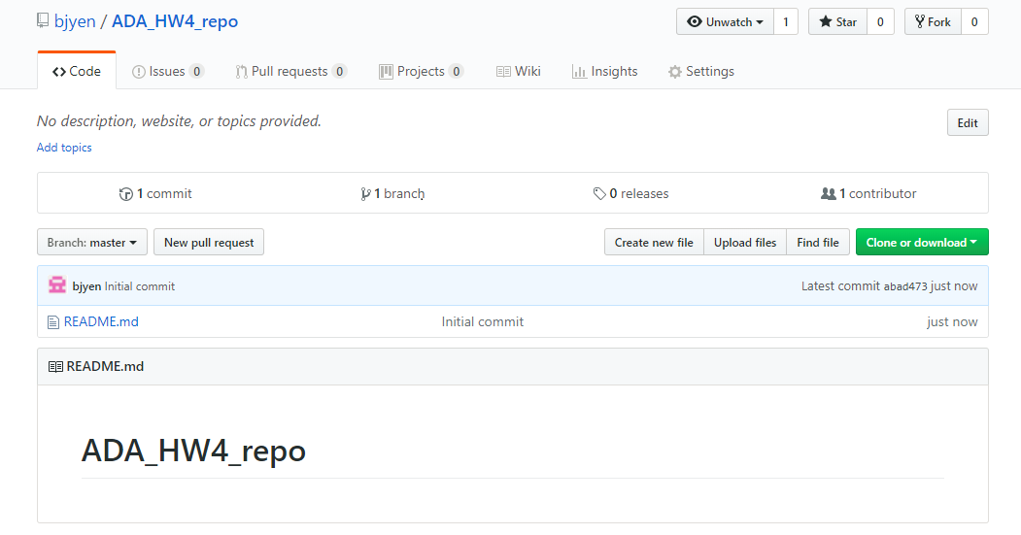

# Clone your Github repository entitled “HW4_repo” to your local computer and save it to a location on your computer. (take a screen shot of the cloned respository at the location on your computer)

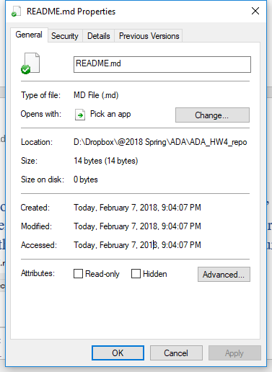

# Open GitBash and use cd ‘ﬁle path’ at the command prompt to change your master to the “HW4_repo” local repository. (take a screen shot of your command)

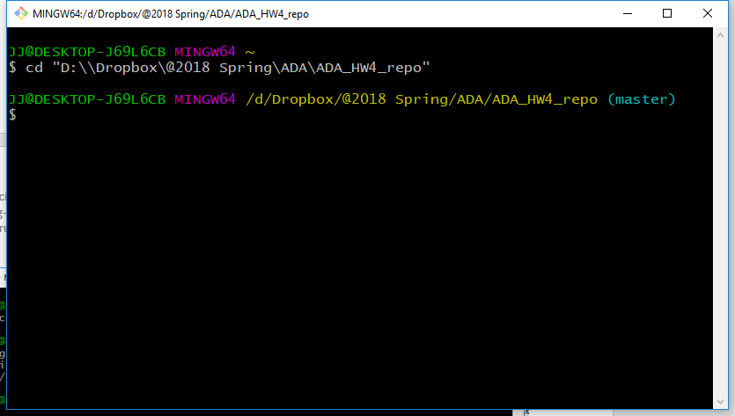

# Initialize a git repository to put the “HW4_repo” local repository under local version control.(take a screen shot of your command)

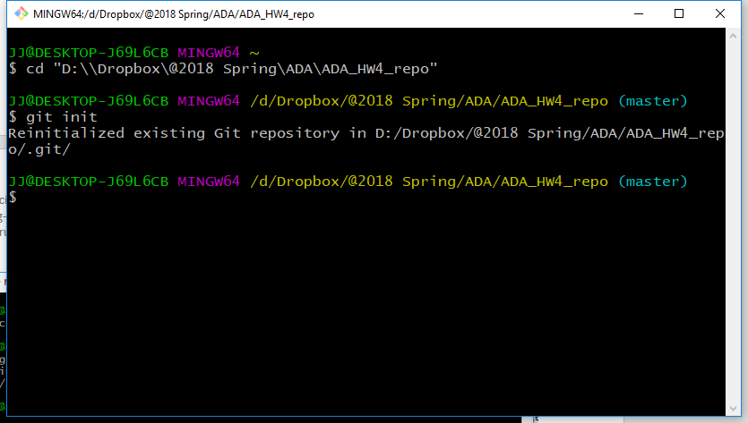

# Create a text ﬁle called helloworld3.txt with the words inside ‘hello there again’ and put it in your “HW4_repo” local respository.(take a screen shot of the HW4_repo showing the ﬁle)

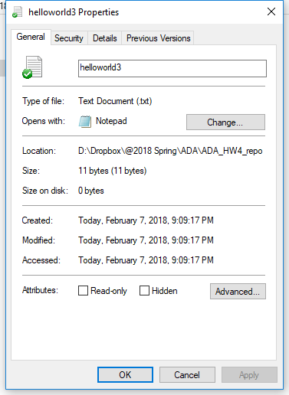

# Set your remote origin to your “HW4_repo” on Github.

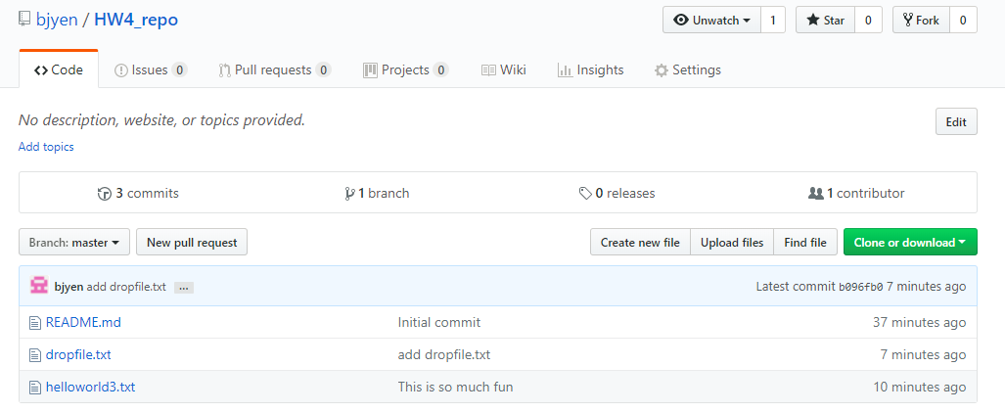

# Add, commit, and push your helloworld3.txt ﬁle to your “HW4_repo” repository on github [hint if you get an error on pushing try adding a -f for force to your command (git push -f origin master)]. (take a screen shot(s) of your commands)

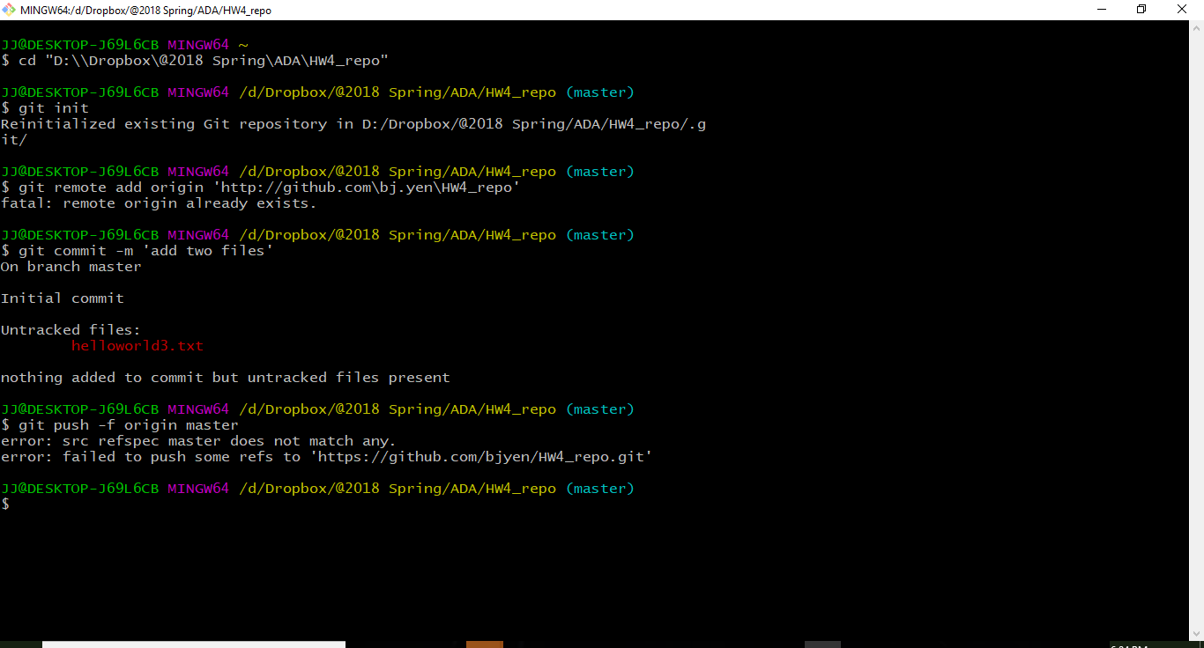

# Make an edit to the helloworld3.txt contents ‘hello there, this is super fun!’, save it, and repeat step 9. (take a screen shot(s) of your commands and messages that indicate success)

# Pulling ﬁles from your remote repository to your local repository

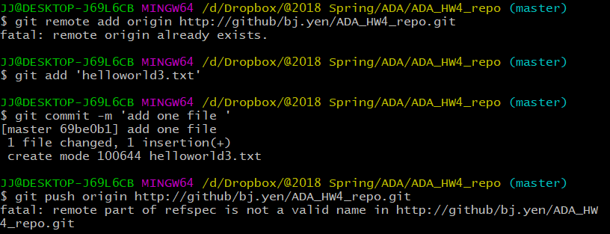

# Create and drop a ﬁle called dropﬁle.txt in your “HW4_repo” on Github. (take a screen shot of the HW4_repo on Github with the ﬁle called dropﬁle.txt in it)

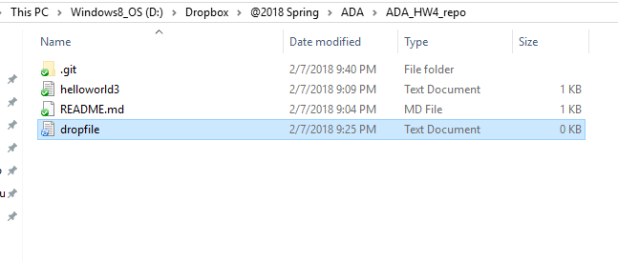

# Go to GitBash and pull any ﬁles (i.e. dropﬁle.txt) to your local repository.(take a screen shot(s) of your commands and messages that indicate success)

(Not working to push from locoal to github…)